Calculator Free Section

1. [6 marks]

Points A and B have position vectors 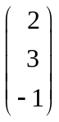 and 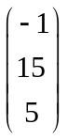 respectively.
Find the point C such that AB : AC = 3 : 5.

2. [12 marks]
For each of the following functions, find .
(a) 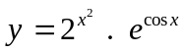

[4]

(b) 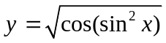

[4]
(c) 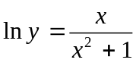

[4]
3. [5 marks]

Use de Moivre’s rule to determine the exact value of 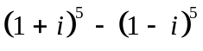.
4. [4 marks]

For each of the following statements, circle either True or False.
If a statement is true, prove that it is true, showing your reasoning clearly.
If a statement is false, either explain why it is false, or provide an example to show the statement is false.

(a) The vector c = –2i – 3j + k is perpendicular to both the vectors
a = –2i + 2j + 2k and b = i – 3j – 7k.

TRUE / FALSE

[2]

(b) If the matrices MN and NM are both defined, then the size of the matrices MN and NM is the same as the size of matrix M or matrix N.

TRUE / FALSE

[2]
5. [5 marks]

Evaluate the following limits, showing full reasoning.

(a) 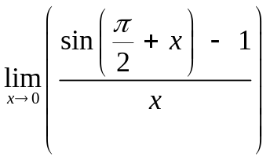

[2]

(b) 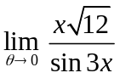

[3]
6. [5 marks]

In triangle ABC, point D is on BC such that AD is perpendicular to BC
and |DB| = |DC|.

Prove that triangle ABC is an isosceles triangle.
7. [3 marks]

There are four types of predators on the island that take chicks from the nest; cats, rats, lizards and gulls. The matrix P shows the proportion of chicks lost each day to each type of predator at each site.

P = [0.015 0.01 0.005 0.018]
cats rats lizards gulls

The number of chicks at each nesting sites A, B and C in 2006 is given by the matrix

C = 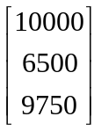
(a) Which of the matrix products PC or CP is defined? Explain why.

[1]

(b) (i) Form the matrix product that is defined and call it R.

(ii) Explain the meaning of the information that matrix R contains.

[2]
Calculator Assumed Section

1. [6 marks]

Determine the equation of the plane which passes through A <3, 2, 6>, B <1, –3, 10> and
C <10, 0, 5>.

2. [6 marks]
A plane passes through the point A (2, –3, 4) and has a normal vector of 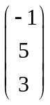.
A line passes through B (16, –17, –8) and is parallel to the vector 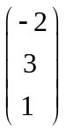.
Determine where the line and plane intersect.

3. [12 marks]

Let W = 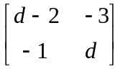, X = 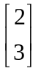, Y = 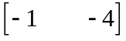 and Z = 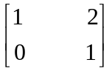.

(a) Evaluate each of the following where possible. If not possible, state this clearly and indicate the reason for your decision.

(i) WX

[2]

(ii) 2Y + Z

[2]

(b) Determine W⁻¹ , stating all the necessary restrictions on d so that W⁻¹ exists.

[4]
(c) Determine the matrix M which satisfies the equation:

MZ – M = 2I

where I is the 2 2 identity matrix.

[4]
4. [10 marks]

ABCD is a parallelogram with points E and F such that AE : EB = 1 : 2 and
BF : FC = 1 : 3. G is the point where AF and ED intersect.

Let Let  = a and  = d.

Determine in what ratios AF and ED intersect each other.
5. [6 marks]

Use the method of proof by exhaustion to prove that every integer which is a perfect cube is either a multiple of 9, or 1 more, or 1 less than a multiple of 9.
6. [5 marks]

(a) Convert z = 6 cis 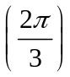 to exact rectangular form.

[1]

(c) If w and z are both complex numbers, show that 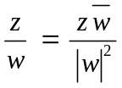.

[4]
7. [5 marks]

Determine the equation of the tangent to the curve defined by 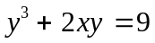
at the point P whose coordinates are (4, 1).
8. [7 marks]

(a) Write down the inequalities on the modulus and argument of the complex number z such that together they describe the set of points shaded below.

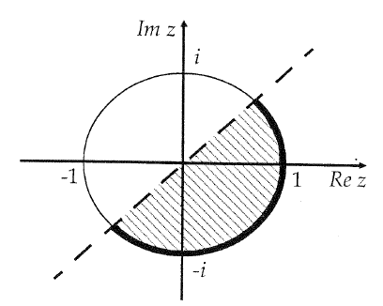

[3]

(b) On the Argand plane provided, indicate the region defined by:

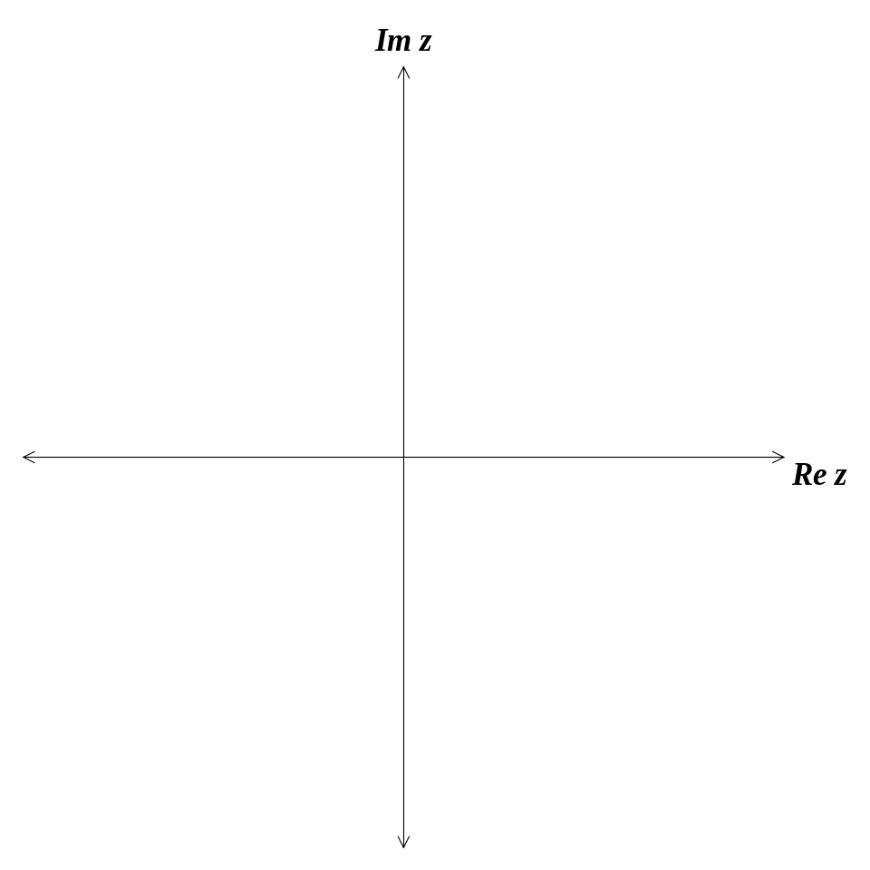 {z : 3 |z – 4i| 4}  {z : 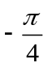 Arg (z – 4i) }

[4]
9. [10 marks]
Two fighter jets are on a practice flight. At time t = 0 seconds, Jet A is at position 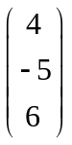 km and jet B is at position 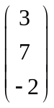 km. Jet A is flying at a velocity of 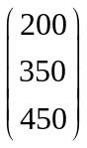 m/s while jet B has a velocity of 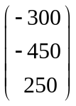 m/s.

(a) At what time are the two jets closest to each other?

[6]
(b) Calculate the shortest distance between the two jets.

[4]
10. [9 marks]

A ladder 13 metres long rests against a vertical wall. If the bottom of the ladder slides away from the wall at the rate of 0.5 m/sec, and the bottom of the ladder is 5 feet from the wall,

(a) how fast is the top of the ladder sliding down the wall?

[5]

(b) at what rate is the angle between the ladder and the ground changing?

[4]
11. [4 marks]

The system of equations

2x + y + 7z = 9556
3x + y + 4z = 5899
5x + 2y + z = 3155

can be used to estimate the number of cats (x), rats (y), and lizards (z), on an island used as a nature reserve.

(a) Write this system of simultaneous linear equations in matrix form.

[1]

(b) Write down the inverse matrix that can be used to solve this system of simultaneous linear equations.

[1]

(c) Solve the system of simultaneous linear equations and hence estimate the number of cats, rats and lizards on the island.

[2]

